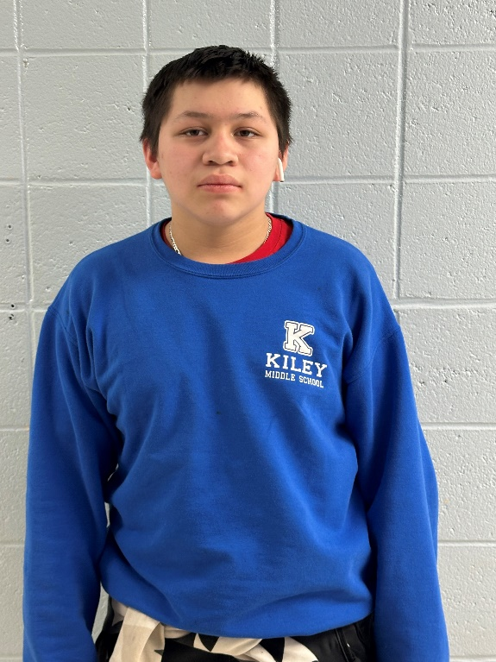

Congratulations to Kiley Prep's very own Fredy Pascual! Fredy is an 8th grade student on his way to greatness. Students in Ms. Rivers' Intervention class were tasked to complete a financial literacy course through FutureSmart. Once completed, they chose a prompt to write an essay about how what they learned in the course will influence their future. These essays were then submitted for a potential college scholarship.

Fredy was picked as one of 3 contest winners and earned a $2,000 scholarship towards the future college of his choice. We are so proud of how hard he works and know he has a bright future ahead. Details of the scholarship can be found by clicking the link below.

[https://futuresmart.massmutual.com/en/scholarship/](https://nam10.safelinks.protection.outlook.com/?url=https%3A%2F%2Ffuturesmart.massmutual.com%2Fen%2Fscholarship%2F&data=05%7C02%7Cjonesjan%40springfieldpublicschools.com%7Cb6c99d9ebdb7404313a908dc2e240960%7C2fcc5063f55c4f40b6b8b845f6b3019f%7C0%7C0%7C638435979557331063%7CUnknown%7CTWFpbGZsb3d8eyJWIjoiMC4wLjAwMDAiLCJQIjoiV2luMzIiLCJBTiI6Ik1haWwiLCJXVCI6Mn0%3D%7C0%7C%7C%7C&sdata=CKrXfCAGQfEYdK%2Bj1y1nDvAPZQhuVIT5QiyWpe7o2bE%3D&reserved=0)

|  |  |
| --- | --- |
| [A group of children smiling  Description automatically generated](https://nam10.safelinks.protection.outlook.com/?url=https%3A%2F%2Ffuturesmart.massmutual.com%2Fen%2Fscholarship%2F&data=05%7C02%7Cjonesjan%40springfieldpublicschools.com%7Cb6c99d9ebdb7404313a908dc2e240960%7C2fcc5063f55c4f40b6b8b845f6b3019f%7C0%7C0%7C638435979557340013%7CUnknown%7CTWFpbGZsb3d8eyJWIjoiMC4wLjAwMDAiLCJQIjoiV2luMzIiLCJBTiI6Ik1haWwiLCJXVCI6Mn0%3D%7C0%7C%7C%7C&sdata=GdTHbIq9USAdijirTk89gPRVtagfnNPZXJd%2BYJRtW58%3D&reserved=0) | [Scholarship Contest | FutureSmart](https://nam10.safelinks.protection.outlook.com/?url=https%3A%2F%2Ffuturesmart.massmutual.com%2Fen%2Fscholarship%2F&data=05%7C02%7Cjonesjan%40springfieldpublicschools.com%7Cb6c99d9ebdb7404313a908dc2e240960%7C2fcc5063f55c4f40b6b8b845f6b3019f%7C0%7C0%7C638435979557346707%7CUnknown%7CTWFpbGZsb3d8eyJWIjoiMC4wLjAwMDAiLCJQIjoiV2luMzIiLCJBTiI6Ik1haWwiLCJXVCI6Mn0%3D%7C0%7C%7C%7C&sdata=5D1Grl9z6%2F0d%2B1aLAZEW6s4GtXtZy7J4YXQlyBOIi5U%3D&reserved=0)  As a FutureSmart student, you’re eligible to enter the 2022-2023 scholarship contest for a chance to be awarded a $1,000 gift card to a 529 college savings plan. The FutureSmart Scholarship Contest is open to any U.S. student in grades 6-8 who has completed at least three of the FutureSmart digital lessons.  futuresmart.massmutual.com |